Task 2- video game analysis

1. The highest amount of games where released in the year 2008 and from the year 2001 to 2012 there is a constanty in the amount of games released.which shows the those where the years games became popular and players are high.

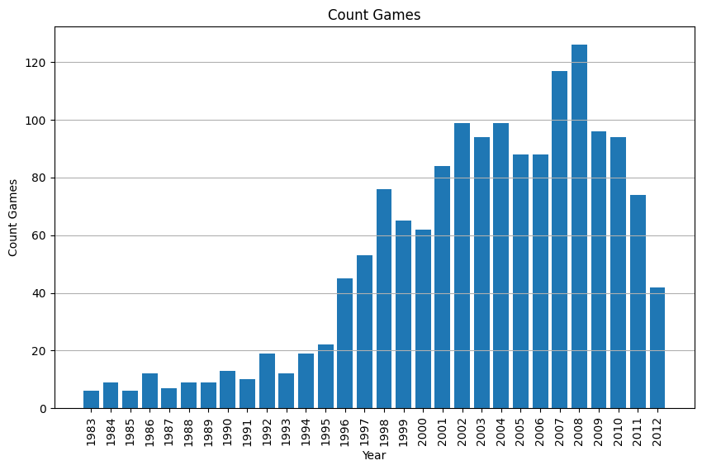

1. Almost all the games have a high amount of reviews, but the highest-reviewed game was the legend of Zelda: ocarina of time.which means the game has more reach among audience.

1. The game genre that has the highest market share is sports and the genre that holds least is strategy.

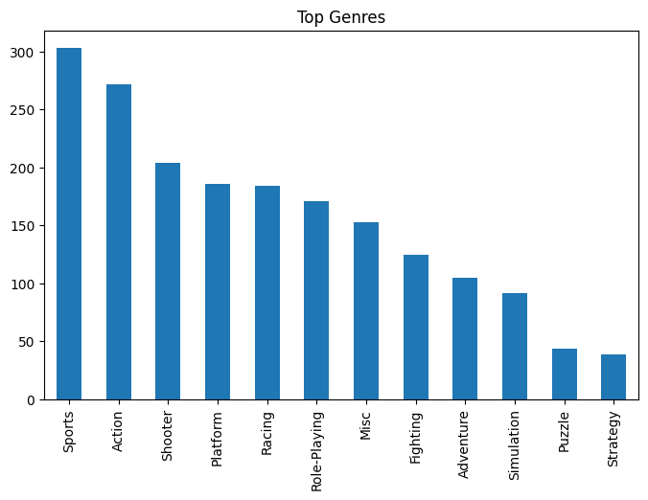

1. From the data we could understand that top 5 years that has highest game releases where 2004,2007,2008,2009 and 2010.and the highest genre released on those years where sports and actions.

1. The highest publisher of games is electronic arts and the lowest publishers are Bethesda softworks.

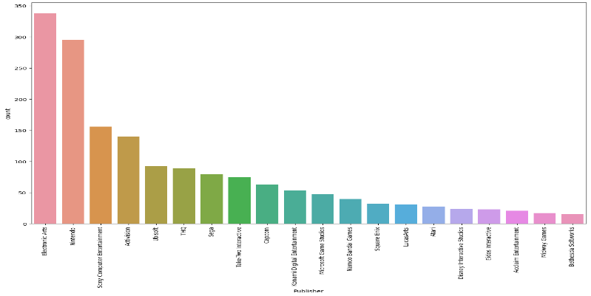

1. From the data, we could understand the highest number of games were launched by the in the platform PS2 and the lowest number of games were launched by the platform psv.

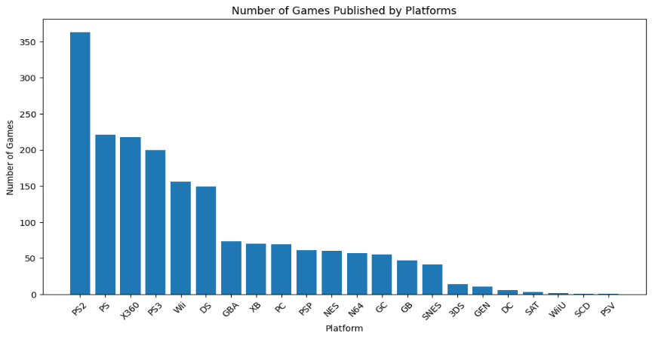

1. The publisher with the highest number of games is: Electronic Arts and the Number of games published by the highest publisher: 338.